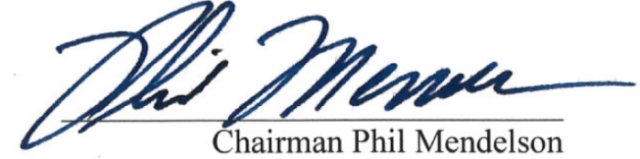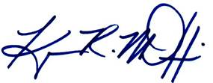______________________________ ______________________________

Councilmember Kenyan McDuffie Chairman Phil Mendelson



___________________________ ______________________________

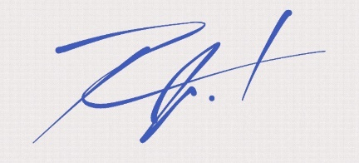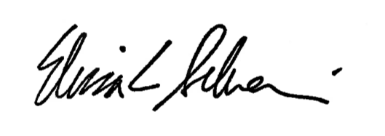Councilmember Anita Bonds Councilmember David Grosso

______________________________ ______________________________

Councilmember Elissa Silverman Councilmember Robert C. White, Jr.

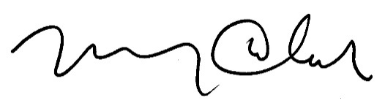

______________________________ ______________________________

Councilmember Brianne K. Nadeau Councilmember Mary M. Cheh

______________________________ ______________________________

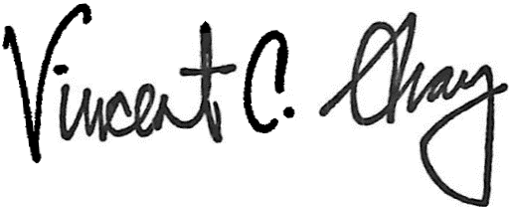Councilmember Brandon Todd Councilmember Charles Allen

______________________________ ______________________________

Councilmember Vincent C. Gray Councilmember Trayon White, Sr.

A PROPOSED RESOLUTION

IN THE COUNCIL OF THE DISTRICT OF COLUMBIA

To declare the existence of an emergency with respect to the need to provide additional protections to Districts residents and businesses during the current public health emergency.

RESOLVED BY THE COUNCIL OF THE DISTRICT OF COLUMBIA, That this resolution may be cited as the “Coronavirus Omnibus Emergency Declaration Resolution of 2020”.

Sec. 2. (a) On March 11, 2020, the Mayor of the District of Columbia issued Mayor’s Order 2020-45, 2020-46, and 2020-63, declaring a public emergency and a public health emergency in the District due to the imminent threat to the health, safety, and welfare of District residents posed by the spread of COVID-19. That order is currently in effect through May 15, 2020. Additional orders extending the emergency are likely to be issued.

(b)(1) As a result of COVID-19 and/or the Mayor’s Order, many District businesses have been required to close, in full or in part. Many of the District’s businesses have business interruption insurance policies that cover losses from such a partial or total shut down due to “physical loss or damage” or orders of “Civil Authority.” However, it appears that many insurers contend that their policies do not provide coverage for these business interruption losses being experienced due to COVID-19 and/or the Order(s), either because the insurer construes ambiguous policy language against the insured or because the insurance policies contains an express exclusion that the insurer argues is applicable to COVID-19. It is necessary to ensure that the District’s businesses who are experiencing financial distress resulting from COVID-19 or the Orde(s)r be able to collect promptly insurance proceeds from their existing business interruption insurance.

(2) Small businesses are the backbone of the District’s economy. Without coverage from insurance, many small businesses in the District will fail. For example, pursuant to the Mayor’s Orders, restaurants and retailers in the District have been forced to close completely or to limit service to delivery or low-contact pick-up. The District’s Chief Financial Officer told the Council that as many as 20% of the District’s restaurants are in danger of not reopening once restrictions are lifted. Industry groups told the Council that the food and beverage industry employs over 65,000, and the retail trade, sports, arts, and entertainment industry—which have been completely closed—employ nearly 5,000 people. More broadly, the 29,000 businesses in the District with fewer than 100 employees employ more than 200,000 workers.

(3) Not surprisingly, the impact to the District’s small businesses have created an economic emergency. More than 85,000 District residents have applied for unemployment insurance. The District’s Chief Financial Officer estimates that, largely because of the business losses in the District and the associated loss of household income, the District government will lose as much as $3.2 billion in revenue over the course of our four-year financial plan. That loss of revenue endangers the District’s ability to carry essential services for its residents and the tens of thousands of regional residents, and tourists from around the world, who work in and visit the District every day. It is essential that the District government find ways to ensure that as many businesses as possible survive and continue to pay employees, including by ensuring that legitimate insurance claims are paid.

(4) The District government has a long history of legislating to protect small, locally owned businesses. For example, the District government requires many government contracts to include minimum amounts of participation from small businesses, and in the Fiscal year 2020 budget, the Council provided tax credits limited to small retailers in the District. Before the Mayor declared a public health emergency, the Council’s Committee on Business and Economic Development was considering three additional pieces of legislation that would provide additional support for small businesses, in particular because of the part that small businesses play in the history and culture of the District and its neighborhoods.

(5) The Council has heard from many small businesses who have had potentially

legitimate claims denied because its insurer has construed ambiguous policy language against the insured or because the insurance policies contains an express exclusion that the insurer argues is applicable to COVID-19, and news reports indicated that, in some instances in other states, even when a policy has seemingly unambiguous language that should provide coverage for loss, claims are still being denied. Many small businesses have neither the resources to hire counsel to win nor the reserve to stay afloat while waiting for a resolution to a claim that may be contested over months or years.

(6) Because of the huge impact on small businesses and the District’s strong

interest in protecting its small businesses, workers, and broader economy, there is a clear economic emergency necessitating the need for the Council to ensure that all legitimate business interruption insurance claims made by the most vulnerable businesses in the District are paid promptly, subject to policy limits, during the recently declared public health emergency. It is also necessary to establish a procedure whereby insurers can be reimbursed for payment of claims that may be affected by this legislation, and to ensure that insurers have a clear process to challenge any determination made pursuant to the provisions of section 2 of the Coronavirus Omnibus Emergency Amendment Act of 2020 that the insurer believes was incorrectly made.

(c) Due to the closure of non-essential businesses, alcohol licensees face obstacles to providing and maintaining licenses. Additionally, ANCs face challenges in reviewing licenses within their jurisdiction. As such, it is necessary to allow non-notarized signatures on an application for licensure, extend the review period for Advisory Neighborhood Commission to provide input on licenses, and to extend the number of days an establishment has to surrender a license.

(d) To aid restaurants while they are unable to provide unrestricted dine-in service, it is necessary to cap the commission fee that third-party food delivery platforms may charge a restaurant to a maximum of 15% of the purchase price on delivery or pick-up orders and to require third-party food delivery platforms to disclose fees to the customer where the restaurant allows such disclosure.

(e) Four individuals currently serving on the University of the District of Columbia’s Board of Trustees are set to have their terms expire on May 15, 2020. In order to make sure that the Board can continue operating effectively and not experience quorum issues, it is necessary to amend the terms for certain Board of Trustee members.

(f) During emergencies, the internet can provide critical information to residents about social services, government operations, and ways to stay engaged with the community. According to data from the Census Bureau, approximately 22% of households with incomes of less than $30,000 do not have access to the internet. During this public health emergency, it is necessary to establish mechanisms that allow these households to access the internet.

(g) For the health and well-being of District residents, the DC Board of Elections is encouraging voters to request absentee (mail-in) ballots for the primary election on June 2nd and the special election for Ward 2 on June 16th. In order to make the process of requesting a ballot as easy as possible, it is imperative to make changes to the petitioning requirements for ballot access.

(h) Advisory Neighborhood Commissions (ANCs) are a vital component of District government, providing advice and insight on critical matters such as planning, social service programs, and public safety in their neighborhoods. To enable ANCs to better respond to the needs of their neighborhood during this public health emergency, it is necessary to expand their grant-making authority.

(i) Long-term care facilities in the District house population that are particularly vulnerable to COVID-19. As of April 24, 2020, at least 13 nursing homes in the District have reported about 200 infections and roughly 15 fatalities. To ensure that the nurses providing care to these residents can do so safely and effectively, it is crucial to provide enhanced protections to these nurses.

(j) As of April 28, 2020, 131 residents in DC jail facilities have tested positive for COVID-19 and one individual has died. Conditions in the facilities have led to lawsuits and ongoing monitoring of DOC practices to keep residents safe. For the Council and the public to have the best possible information on developments occurring within DC jail facilities, it is vital to prescribe reporting requirements.

(k) As part of the Sustainable Solid Waste Management Act of 2014, the District established incentives for composting and explicitly residents to engage in residential composting to reduce waste. To continue to promote sustainable waste practices during this public health emergency, it is crucial to allow virtual composting trainings.

(l) As District residents grapple with the economic consequences of this public health emergency, it is incumbent that the government provide mechanisms to relieve the financial strain families are experiencing. As such, it is necessary to enable tenants and residents to establish payment plans for rental units and utility services.

Sec. 3. The Council of the District of Columbia determines that the circumstances in section 2 constitute emergency circumstances, making it necessary that the Coronavirus Omnibus Emergency Amendment Act of 2020 be adopted after a single reading.

Sec. 4. This resolution shall take effect immediately.