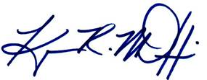______________________________ ______________________________

Councilmember Kenyan McDuffie Chairman Phil Mendelson



___________________________ ______________________________

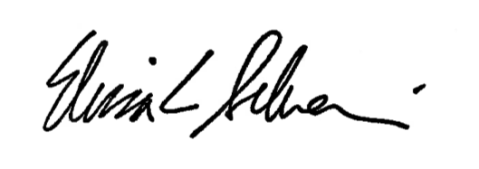Councilmember Anita Bonds Councilmember David Grosso

______________________________ ______________________________

Councilmember Elissa Silverman Councilmember Robert C. White, Jr.

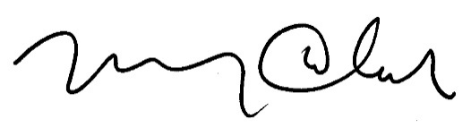

______________________________ ______________________________

Councilmember Brianne K. Nadeau Councilmember Mary M. Cheh

______________________________ ______________________________

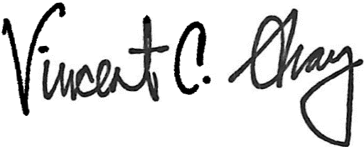Councilmember Brandon Todd Councilmember Charles Allen

______________________________ ______________________________

Councilmember Vincent C. Gray Councilmember Trayon White, Sr.

A PROPOSED RESOLUTION

______________

IN THE COUNCIL OF THE DISTRICT OF COLUMBIA

__________________

To declare the existence of an emergency with respect to the need to clarify tenant payment plans, commercial rent increases during a public health emergency small business microgrant eligibility, grants for promoting coronavirus awareness, rules for serving alcohol on expanded outdoor restaurant seating, and COVID-19 leave; and to add provisions related to emergency credit alerts, living wills, approval of a contract under Council review, and designation of Black Lives Matter plaza.

RESOLVED BY THE COUNCIL OF THE DISTRICT OF COLUMBIA, That this resolution may be cited as the “Coronavirus Support Clarification Emergency Declaration Resolution of 2020.”

Sec. 2. (a) On May 19, 2020, the Council adopted the Coronavirus Support Congressional Review Emergency Amendment Act of 2020. Following the passage of that act, stakeholders and staff identified certain provisions of law that need to be clarified or amended to effectuate the Council’s intent.

(b) The proposed modifications include clarifying provisions, technical amendments or other minor amendments that must go into effect immediately to clarify the law and provide the necessary coronavirus-related supports.

(c) There are also proposed new provisions including rules to allow for alcoholic beverage consumption on expanded outdoor restaurant patios, a new microgrant program to assist with the District’s coronavirus response, and living will declarations.

(d) There is also a need to approve a contract related to COVID-19 relief funding from EventsDC to hotels, restaurants, and excluded workers.

(e) During the public health emergency, peaceful protesters in the District were also confronted by Federal law enforcement officials who drove back protesters a number of blocks from the White House. In response, the Mayor declared several blocks of 16th street as “Black Lives Matter Plaza” and this emergency vehicle will allow for the Council to complete the symbolic naming.

Sec. 3. The Council of the District of Columbia determines that the circumstances in section 2 constitute emergency circumstances, making it necessary that the Coronavirus Support Clarification Emergency Amendment Act of 2020 be adopted after a single reading.

Sec. 4. This resolution shall take effect immediately.