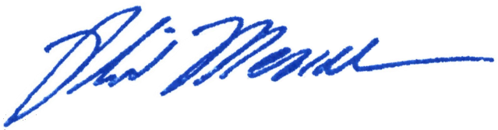
____________________________
Chairman Phil Mendelson

A PROPOSED RESOLUTION

_________

IN THE COUNCIL OF THE DISTRICT OF COLUMBIA

__________________

To appoint Ms. Schannette Grant as the Interim Executive Director of the Office of Advisory Neighborhood Commissions.

RESOLVED, BY THE COUNCIL OF THE DISTRICT OF COLUMBIA, That this resolution may be cited as the “Interim Executive Director of the Office of Advisory Neighborhood Commissions Schannette Grant Appointment Resolution of 2001”.
Sec. 2. The Council of the District of Columbia appoints:
Schannette Grant
80 V Street NW
Washington, D.C. 20001
(Ward 2)

as the Interim Executive Director of the Office of Advisory Neighborhood Commissions, established by section 18(a) of the Advisory Neighborhood Commissions Act of 1975, effective March 28, 2000 (D.C. Law 13-135; D.C. Official Code § 1-309.15(a)), on an at will basis, replacing Mr. Gottlieb Simon.
Sec 3. The Council of the District of Columbia shall transmit a copy of this resolution, upon its adoption, each to the appointee and to the Office of the Mayor.
Sec. 4. This resolution shall take effect immediately.

