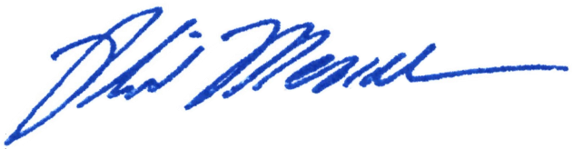
______________________________
Chairman Phil Mendelson

A PROPOSED RESOLUTION

_______

IN THE COUNCIL OF THE DISTRICT OF COLUMBIA

__________________

To declare the existence of an emergency, with respect to the need to amend the Ward Redistricting Amendment Act of 2021 and the Ward Redistricting Emergency Amendment Act of 2021 to make technical corrections to the 2022 Ward boundaries.

RESOLVED BY THE COUNCIL OF THE DISTRICT OF COLUMBIA, That this resolution may be cited as the “Ward Redistricting Technical Corrections Emergency Declaration Resolution of 2022.”
Sec. (a) The Ward Redistricting Amendment Act of 2021, enacted December 29, 2021, 2021 (D.C. Act 24-265) (“Act”) and the Ward Redistricting Emergency Amendment Act of 2021, enacted December 29, 2021 (D.C. Act 24-264) (“Emergency Act”), established the new ward boundaries to be effective January 1, 2022.
(b) After the Office of Planning used the legislation to create the maps for the new Ward boundaries, two minor technical errors were discovered:
(A) A missing leg of the Ward 6 boundary that was included in the corresponding Ward 5 boundary; and
(B) A directional error with regard to the Ward 7 boundary that was correct in the corresponding Ward 6 boundary.
(c) It is necessary to make these two technical corrections to both the Act and the Emergency Act given the new ward boundaries have taken effect.
(d) The changes will be made on a permanent basis as part of the Technical Amendments Act of 2022 (Bill 24-502) scheduled for markup by the Committee of the Whole on January 18, 2022.
Sec. 3. The Council of the District of Columbia determines that the circumstances in section 2 constitute emergency circumstances, making it necessary that the Ward Redistricting Technical Corrections Emergency Amendment Act of 2022 be adopted after a single reading.
Sec. 4. This resolution shall take effect immediately.

