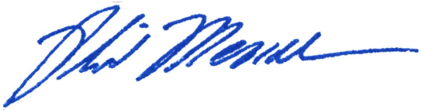
_____________________________
Chairman Phil Mendelson

AN AMENDMENT
B24-690, “Community Service Graduation Requirement Waiver Regulation Emergency Amendment Act of 2022”
March 1, 2022

Amendment:
(a) Section 3 is redesignated as Section 4
(b) Section 4 is redesignated as Section 5
(c) A new section 3 is added to read as follows:
“Sec. 3. The District of Columbia Public Records Management Act of 1985, effective September 5, 1985 (D.C. Law 6-19; D.C. Official Code § 2-1701 et seq.), is amended as follows:
“(a) Section 2(13) (D.C. Official Code § 2-1701(13)) is amended by striking the phrase “electronic mail” and inserting the phrase “electronic mail or other communications transmitted electronically, including through any electronic messaging service” in its place.
“(b) Section 7(a)(1) (D.C. Official Code § 2-1706(a)(1)) is amended as follows:
“(1) Strike the phrase “official business” and insert the phrase “official business, including
records created or received electronically,” in its place.
“(2) Strike the phrase “in any manner” and insert the phrase “in any manner, including
through the enabling of settings on electronic devices that allow for the non-retention or automatic deletion of records”

Rationale: This amendment would incorporate the provisions of the Bill 24-692, the “Fidelity in Access to Government Communications Clarification Emergency Amendment Act of 2022” into a Temporary bill, given the Committee failed to notice a standalone accompanying temporary act. This will ensure that the law is in effect for more than 90 days while permanent legislation is considered.

