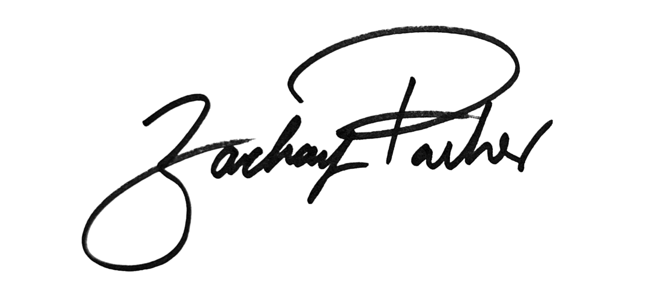
_________________________
Councilmember Zachary Parker

AN AMENDMENT

#4

IN THE COUNCIL OF THE DISTRICT OF COLUMBIA

DATE: May 16, 2023
OFFERED BY: Councilmember Zachary Parker
TO: Bill 24-0203, Fiscal Year 2023 Local Budget Act of 2023
Version: ___ Introduced
___ Committee Report
___ Committee Print
_X First Reading
___ Engrossed
___ Enrolled
___ Amendment in the Nature of Substitute

The $331,071,000 of revenue generated in FY24 and over the financial plan by Parker Amendment #3 to Bill 24-202, the Fiscal Year 2024 Budget Support Act of 2023, which adds Subtitle K, the Deed Recordation and Transfer Taxes Amendment Act of 2023, shall be allocated as follows:

(1) Fund Parker Amendment #1 to Bill 24-202, the Fiscal Year 2024 Budget Support Act of 2023, which adds the Child Tax Credit Amendment Act of 2023, Subtitle J in recurring in local funds as follows:

 | FY2024 | FY2025 (TY2024) | FY2026 (TY2025) | FY2027 (TY2026) | FY2024-FY2027
Credit estimate |  | 19,133,000 | 19,228,000 | 19,324,000 | 57,685,000
Underlying population increase |  |  | 0.004965243 | 0.004992719 | 0.009958
pop+inf |  |  | 102.7% | 102.7%
Total revenue impact ($ in thousands) |  | 19,133,000 | 19,649,000 | 20,179,000 | 58,961,000
Admin estimates: systems | TBD | TBD | TBD | TBD | TBD
Admin estimates: FTE | TBD | TBD | TBD | TBD | TBD
Total | TBD | TBD | TBD | TBD | TBD
 | FY2024 | FY2025 | FY2026 | FY2027
CPI-W (DC) | 2.5% | 1.9% | 2.2% | 2.2%

(2) Fund the Give SNAP a Raise Amendment Act of 2022, effective March 10, 2023 (D.C. Law 24-301; 70 DCR 581), in recurring in local funds as follows:

Increase CSG xxx, in Program xxxx, in Activity xxxx, Service Code xxxx, as follows:
Give SNAP a Raise Fiscal Impact Statement
Total Costs
 | FY 2024 | FY 2025 | FY 2026 | FY 2027 | Total
Benefits | $26,351,000 | $53,664,000 | $54,576,000 | $55,504,000 | $190,095,000
Admin (IT) | $300,000 |  |  |  | $300,000
Total spending | $26,651,000 | $- | $- | $- | $190,395,000

(3) Fund the No Senior Hungry Omnibus Amendment Act of 2022, effective March 10, 2023 (D.C. Law 24-294; 70 DCR 560), in recurring in local funds as follows:

No Senior Hungry Fiscal Impact Statement
Total Costs
 | FY 2024 | FY 2025 | FY 2026 | FY 2027 | Total
DACL Costs
Salaries | $433,000 | $441,000 | $449,000 | $457,000 | $1,780,000
Fringe | $103,000 | $105,000 | $107,000 | $110,000 | $425,000
Contractor | $100,000 |  |  |  | $100,000
NPS | $96,000 | $98,000 | $100,000 | $102,000 | $396,000
Total DACL Costs | $732,000 | $644,000 | $656,000 | $669,000 | $2,701,000
DHS Costs
Salaries | $0 | $193,000 | $196,000 | $199,000 | $588,000
Fringe |  | $47,000 | $48,000 | $49,000 | $144,000
Systems changes | $600,000 |  |  |  | $600,000
Grants | $250,000 | $254,000 | $258,000 | $263,000 | $1,025,000
Total DHS Costs | $850,000 | $494,000 | $502,000 | $511,000 | $2,357,000
OSSE Costs | $15,000 | $15,000 | $16,000 | $16,000 | $62,000
EPD Waiver Costs
Local portion | $0 | $6,869,000 | $6,989,000 | $7,111,000 | $20,969,000
Federal portion | $0 | $16,027,000 | $16,307,000 | $16,592,000 | $48,926,000
 | $0 | $22,896,000 | $23,296,000 | $23,703,000 | $69,895,000
Total costs | $1,597,000 | $24,049,000 | $24,470,000 | $24,899,000 | $69,895,000
Local Funds Portion |  | $8,022,000 | $8,163,000 | $8,307,000 | $26,089,000

(4) Fund/increase the Transitional Employment ("project empowerment") program, $5,000,000 in one time local funds in Fiscal Year 2024:

Transitional Employment ("Project Empowerment")
Item | FY 2023 | FY 2024 | FY 2025 | FY 2026 | FY 2027 | Total
Transitional Employment ("Project Empowerment") | $- | $5,000,000 | $- | $- | $- | $5,000,000

(5) Fund/increase the Marion Barry Summery Youth Employment program, $5,000,000 in one time local funds in FY24:

Marion Barry Summer Youth Employment Program
Item | FY 2023 | FY 2024 | FY 2025 | FY 2026 | FY 2027 | Total
Marion Barry Summer Youth Employment Program | $- | $5,000,000 | $- | $- | $- | $5,000,000

(6) Fund/increase the Early Childhood Educators Pay Equity Fund, $1.2 million per year in recurring local funds for a total of $4.4 million over the plan:

Early Childhood Educators Pay Equity Fund
Item | FY 2023 | FY 2024 | FY 2025 | FY 2026 | FY 2027 | Total
Early Childhood Educators Pay Equity Fund | $- | $4,400,000 | $- | $- | $- | $4,400,000

(7) Increase CSG xxx, in Program xxxx, in Activity xxxx, Service Code xxxx, by $700,000 in one time local funds in Fiscal Year 2024 for the DC Health local home visiting grant program;

Item | FY 2023 | FY 2024 | FY 2025 | FY 2026 | FY 2027 | Total
DC Health local home visiting grant program | $- | $700,000 | $- | $- | $- | $700,000

(8) Increase CSG xxx, in Program xxxx, in Activity xxxx, Service Code xxxx, by $20,000,000 in one time local funds in Fiscal Year 2024 for the Emergency Rental Assistance program;

Emergency Rental Assistance Program
Item | FY 2023 | FY 2024 | FY 2025 | FY 2026 | FY 2027 | Total
Emergency Rental Assistance Program | $- | $20,000,000 | $- | $- | $- | $20,000,000

Excluded Workers
Item | FY 2023 | FY 2024 | FY 2025 | FY 2026 | FY 2027 | Total
Payment to excluded workers | $- | $10,826,000 | $- | $- | $- | $10,826,000

Rationale:

This amendment updates the Fiscal Year 2024 Local Budget Act of 2024 to allocate additional revenue realized from amendments to B25-0203, the Fiscal Year 2024 Budget Support Act of 2023.

