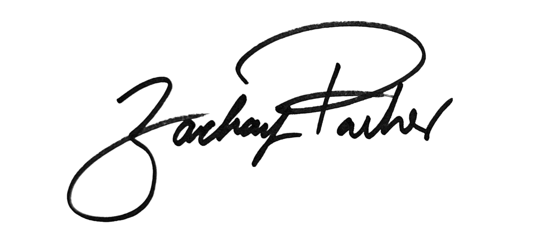
______________________________
Councilmember Zachary Parker

AN AMENDMENT
#2
IN THE COUNCIL OF THE DISTRICT OF COLUMBIA
Date: May 16, 2023
Amendment offered by: Councilmember Zachary Parker
To: B25-0202, the Fiscal Year 2024 Budget Support Act of 2023

Version: First Reading

Page 81, line 1641, Title IV is amended by adding a new subtitle T to read as follows:

“SUBTITLE T. SCHOOL SAFETY COORDINATION
“Sec. 4181. Short title.
“This subtitle may be cited as the “School Safety Coordination Amendment Act of 2023.”
“Sec. 4182. Definitions.
“For purposes of this subtitle, the term:
“(1) “Destructive device” shall have the same meaning as provided in section 101(7) of the Firearms Control Regulations Act of 1975, effective September 24, 1976 (D.C. Law 1-85; D.C. Official Code § 7-2501.01(7)).
“(2) “Circumstance appropriate for police involvement” means:
“(A) A suspected “crime of violence” as that term is defined in D.C. Official Code § 23-1331(4);
“(B) A suspected “dangerous crime” as that term is defined in D.C. Official Code § 23-1331(3);
“(C) A suspected violation of D.C. Official Code § 16-1022;
“(D) The use or possession of a firearm or destructive device on school property or at a school event;
“(E) A credible threat to commit a crime of violence, a dangerous crime, or a violation of D.C. Official Code § 16-1022 on school property or at a school event;
“(F) The presence of a person on school property or at a school event who is subject to:
“(i) A temporary protection order or civil protection order;
“(ii) A temporary or final anti-stalking order; or
“(iii) An extreme risk protection order issued pursuant to Title X of the Firearms Control Regulations Act of 1975, effective May 10, 2019 (D.C. Law 22-314; D.C. Official Code § 7-2510.01 et seq.); or
“(G) Another circumstance identified by the school safety enhancement committee in the report issued pursuant to section 4183.
“(3) “Exclusion” means the removal of a student from the student's daily class schedule for disciplinary reasons and includes a suspension or a disciplinary unenrollment.
“(4) “Firearm” shall have the same meaning as provided in section 101(9) of the Firearms Control Regulations Act of 1975, effective September 24, 1976 (D.C. Law 1-85; D.C. Official Code § 7-2501.01(9)).
“(5) “Local education agency” means the District of Columbia Public Schools system or any individual or group of public charter schools operating under a single charter.
“(6) “School safety employee” means a school employee who is assigned to the school safety team and tasked with responding to safety incidents within the school community. A school safety employee may provide care, mediation, coaching, relationship building, violence interruption and prevention, de-escalation, and mediation services.
“(7) “School safety assistant director” means a school employee whose primary role and responsibility is the safety of students and educators at a public high school and who reports to the school safety director; provided a school safety assistant director shall not be a security guard, school resource officer, or law enforcement officer, and shall not carry a firearm while on duty.
“(8) “School safety director” means a school employee whose primary role and responsibility is the safety of students and educators at a District public school; provided a school safety director shall not be a security guard, school resource officer, or law enforcement officer, and shall not carry a firearm while on duty.
“(9) “School safety coordination guidelines” means the guidelines established pursuant to section 4183.
“(10) “School safety team” means school safety employees at a school, which may include a school safety director and, in the case of a high school, a school safety assistant director. The term shall not include security guards, school resources officers, or law enforcement officers.
“(11) “Trauma informed services” means a service delivery approach that recognizes and responds to the impacts of trauma with evidence-based supports and intervention, emphasizes physical, psychological, and emotional safety for both providers of services and survivors of trauma, and creates opportunities for survivors of trauma to rebuild a sense of healing and empowerment.
“(12) “Law enforcement officer” means:
“(A) An officer, member, or on-duty civilian employee of the Metropolitan Police Department or of any other police force operating in the District;
“(B) An investigative officer or agent of the United States, including an officer or agent of the Department of Homeland Security;
“(C) An on-duty employee of the Department of Corrections or Department of Youth Rehabilitation Services; or
“(D) An on-duty employee of the Court Services and Offender Supervision Agency, Pretrial Services Agency, or Family Court Social Services Division.
“(13) “Restorative justice” means the use of reconciliation to build community, manage conflict, and resolve tensions by repairing the harm caused by individuals toward another and restoring their relationships.
“(14) “Transformative justice” means a political framework and approach for responding to violence, harm, and abuse, which seeks to respond to violence without creating more violence or engage in harm reduction to lessen the violence.
“Sec. 4183. Establishment of the school safety enhancement committee.
“(a) There is established a school safety enhancement committee whose purpose shall be to assist the Deputy Mayor for Education (“DME”) in issuing a report on the roles, functions, and responsibilities that school safety teams, which may include school safety directors, school safety assistant directors, and school safety employees (or equivalent unarmed non-law enforcement personnel) or similar roles would serve and the impact adding these roles would have on existing staff and school budgets.
“(b) Facilities and other administrative support may be provided in a specific department or directly to the Committee, as determined by the DME.
“(c) The school safety enhancement committee shall be comprised of 15 members as follows:
“(1) Six representatives designated by the DME, one of whom shall be the chairperson, as follows:
“(A) One representative affiliated with a parent-led advocacy organization;
“(B) One representative affiliated with an organization with expertise relating to mental or behavioral health;
“(C) Two representatives affiliated with a student-led advocacy organization; and
“(D) Two representatives with at least 5 years of experience as an employee of a local education agency;
“(2) A representative designated by the Deputy Mayor for Public Safety and Justice;
“(3) A representative designated by the State Board of Education;
“(4) A representative designated by the Chancellor of the District of Columbia Public Schools;
“(5) A representative designated by the Public Charter School Board;
“(6) A representative designated by the Washington Teachers’ Union;
“(7) A representative designated by the Office of the Student Advocate; and
“(8) Three representatives designated by the Chair of the Council committee with jurisdiction over the Deputy Mayor for Education.
“(d) The school safety enhancement committee shall consult with the following District agencies to establish guidelines relating to school building security, traffic safety plans, pickup and dismissal safety, emergency operations plans, and procedures for circumstances appropriate for police involvement:
“(1) The Office of the Deputy Mayor for Public Safety and Justice;
“(2) The Metropolitan Police Department;
“(3) The Homeland Security and Emergency Management Agency;
“(4) The Department of Health;
“(5) The Department of Behavioral Health; and
“(6) The Department of Transportation.
“(e) By March 1, 2024, the school safety enhancement committee shall issue a report to the Mayor, the Deputy Mayor for Education, and the Chair of the Council committee with jurisdiction over the Deputy Mayor for Education on:
“(1) Existing school safety roles and responsibilities that are being fulfilled by school employees, security guards, and school resource officers;
“(2) Recommended staffing configurations of a school safety team, including descriptions of possible responsibilities and hiring qualifications of school safety employees.
“(3) Potential career paths and talent pools for members of a school safety team;
“(4) Circumstances appropriate for police involvement in addition to those specified in section 4182(2).
“(5) Evidence-based and trauma-informed approaches to achieving school safety that would improve student learning, safety, and wellbeing that can be provided by a member of the school safety team, including:
“(A) School-wide positive behavior interventions and supports;
“(B) Restorative justice programs and interventions;
“(C) Violence interruption;
“(D) Mediation; or
“(E) Social and emotional learning programs;
“(6) Methods of prevention and intervention that the school safety team may employ to minimize and respond to school safety incidents;
“(7) Student discipline approaches that minimize reliance on exclusion from school and law enforcement responses to student behavior, are aimed at addressing the root causes of behavioral issues, and that ensure that students have access to appropriate mental health, counseling, nutrition, and other services;
“(8) Procedures for contacting and engaging with the Metropolitan Police Department in circumstances appropriate for police involvement that ensure the physical safety, mental health, and well-being of all students and school employees;
“(9) Procedures for enhancing campus security without compromising the privacy of students, including appropriate uses of security cameras and related technology to monitor and respond to campus threats;
“(10) Practices for engaging students and parents in each school community about safety needs, the school’s response to incidents handled by a school safety team, and the school’s response to circumstances appropriate for police involvement;
“(11) Requirements for schools to report safety incidents to the Office of the State Superintendant;
“(12) Protocols for coordination between a school safety team and the safe routes to school program and the safe passage program established pursuant to sections 2a and 2d of the School Proximity Traffic Calming Act of 2000, effective March 10, 2023 (D.C. Law 24-285; D.C. Official Code §§ 38–3102 and -3105.)
“(13) Recommended guidelines for ongoing professional development plans and support for members of a school safety team and other on-site personnel to ensure they are equipped with appropriate training and resources to fulfill their responsibilities, such as:
“(A) Child and adolescent development;
“(B) Cultural and linguistic competency in the cultures reflected in a local education agency’s population;
“(C) Effective communication skills;
“(D) Behavior management;
“(E) Conflict resolution, including restorative and transformative justice practices;
“(F) De-escalation techniques;
“(G) Behavioral health issues for youth and families;
“(H) Child sexual abuse prevention, identification, and response;
“(I) Availability of social services and community resources, including mutual aid, for youth;
“(J) District laws and regulations regarding school discipline;
“(K) Constitutional standards for searches and seizures conducted by school personnel on school grounds;
“(L) Violence interruption and prevention, including gang and crew dynamics;
“(M) Childhood trauma and trauma-responsive care; and
“(N) Non-discrimination related to protected classes established under section 241 of the District Human Rights Act of 1977 (D.C. Official Code § 2-1402.41).

Rationale:
The subtitle establishes a school safety enhancement committee to assist the Deputy Mayor for Education in issuing a report on the roles, functions, and responsibilities that unarmed non-law enforcement personnel could assume in local education agency schools. The committee would include relevant stakeholders, including representatives of key education agencies, parents, students, and the council. Establishing this committee would lay the groundwork for the establishment of new school safety personnel as contemplated in the School Safety Enhancement Act of 2023 that Councilmember Parker introduced earlier this year. The committee would be responsible for issuing a report to the Mayor, Deputy Mayor, and Chair of the D.C. Council Committee of the Whole by March 1, 2024—a deadline that would allow the committee’s work to help inform the council’s deliberations in the FY 2025 budget.

