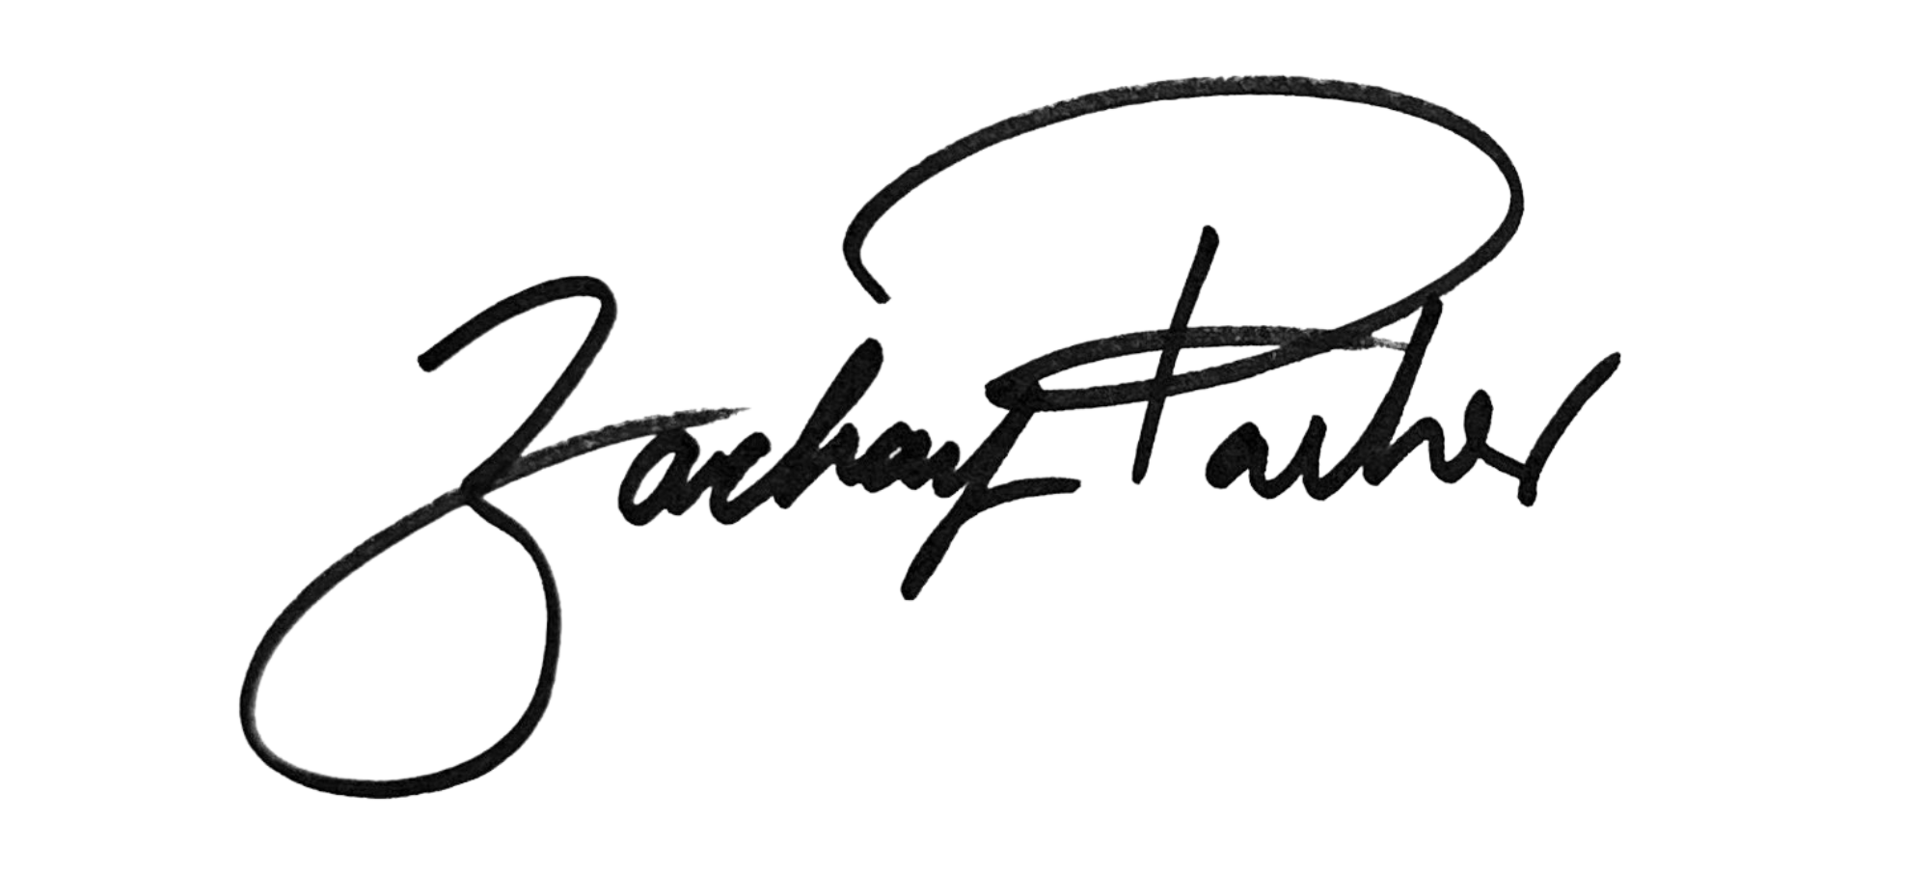
______________________________
Councilmember Zachary Parker

AN AMENDMENT
#1
IN THE COUNCIL OF THE DISTRICT OF COLUMBIA
Date: May 16, 2023
Amendment offered by: Councilmember Zachary Parker
To: B25-0202, the Fiscal Year 2024 Budget Support Act of 2023

Version: First Reading

Title VII is amended by adding a new subtitle J to read as follows:

SUBTITLE J. DISTRICT CHILD TAX CREDIT AMENDMENT ACT OF 2023
Sec. 7098. Short title.
This subtitle may be cited as the “ Child Tax Credit Amendment Act of 2023.”
Sec. 7099. Chapter 18 of Title 47 of the District of Columbia Official Code is amended as follows:
(a) The table of contents is amended by adding a new section designation to read as follows:
“§ 47-1806.17. Child Tax Credit.”.
(b) A new section 47-1806.17 is added to read as follows:
“§ 47-1806.17. Child tax credit.
“(a)(1) For taxable years beginning after December 31, 2023, a taxpayer shall be allowed a credit against the tax imposed under this subchapter of up to $500 for each qualifying child.
“(2) The $500 credit limit per qualifying child set forth in paragraph (1) of this subsection shall be increased annually pursuant to the cost-of-living adjustment; provided that if the adjustment does not result in a multiple of $5, the increase shall be rounded down to the next multiple of $5.
“(3)(A) The amount of the credit allowable under paragraph (1) of this subsection shall be reduced by $20 for each $1,000 (or fraction thereof) by which the taxpayer’s adjusted gross income exceeds the threshold amount; provided, the credit cannot be reduced below zero.
“(B) For purposes of this paragraph, the term “threshold amount” means:
“(i) $100,000 in the case of a single filer; or
“(ii) $145,000 in the case of a joint filer.
“(4) A taxpayer shall not be eligible to receive a credit authorized under this section for a taxable year if:
“(A) The taxpayer does not claim the eligible child as a dependent on the taxpayer’s federal and District income tax returns for that taxable year; or
“(B) A person other than the taxpayer claimed the eligible child as a dependent on his or her federal and District income tax returns for that taxable year;.
“(5) A child may only be claimed once in a married household filing separately.
“(b) The credit allowed under this section in a taxable year may exceed the taxpayer's tax liability under this subchapter for that taxable year and shall be refundable to the taxpayer claiming the credit.
“(c) In the case of a return made for a fractional part of a taxable year, the credit shall be reduced to an amount that bears the same ratio to the full credit provided as the number of months in the period for which the return is made to 12 months.
“(d) Payment made pursuant to this section shall not be considered income for the purpose of determining eligibility or benefit amount for public assistance.
“(e) If a return is filed for a full calendar or fiscal year beginning after December 31, 2025, an individual who is a resident of the District but is not a citizen or resident alien of the United States and who would otherwise qualify for the credit under this section but for the fact that the individual is not a citizen or resident alien of the United States, shall be allowed a credit in the same amounts and to the same extent as provided in this section.
“(g) For the purposes of this section, the term “qualifying child” means a child who is under 12 years old.”.

Rationale:
This amendment will create a child tax credit for qualifying families with children in the District. The revenue generated by repealing the sunset provision for deed transfer and deed recordation tax rates will provide cash to families with children in low and moderate income households, starting with credits allowed in tax year 2024. There will be an option for the credit to be paid out as a lump sum or monthly basic income. There is no work requirement for this benefit meaning it covers families that are not covered by the District’s earned income tax credit.

