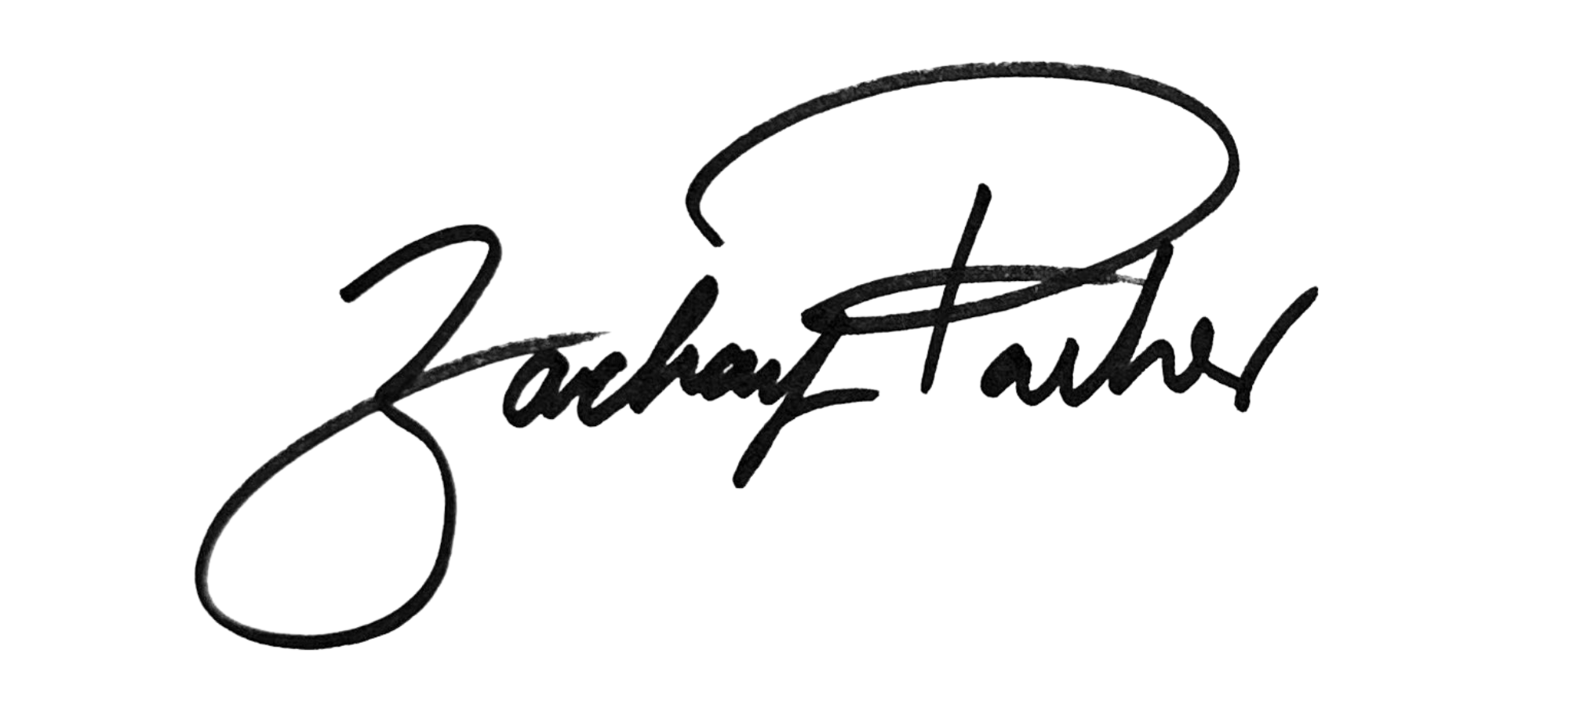
______________________________
Councilmember Zachary Parker

AN AMENDMENT
#3
IN THE COUNCIL OF THE DISTRICT OF COLUMBIA
Date: May 16, 2023
Amendment offered by: Councilmember Zachary Parker
To: B25-0202, the Fiscal Year 2024 Budget Support Act of 2023

Version: First Reading
Title VII is amended by adding a new subtitle Kto read as follows:

“SUBTITLE K. DEED RECORDATION AND TRANSFER TAXES
“Sec. 7100. Short title.
“This subtitle may be cited as the “Deed Recordation and Transfer Taxes Amendment Act of 2023”.
“Sec. 7101. Section 7024 of the Recordation and Transfer Taxes Amendment Act of 2019, effective September 11, 2019 (D.C. Law 23-16; D.C. Official Code §§ 42-1103 & 47-903, note) is amended by striking the phrase “September 30, 2023.” and inserting the phrase “September 30, 2029.” in its place.

Rationale:
This amendment will extend the sunset provision of deed transfer and deed recordation tax rates currently schedule for September 30, 2023 to September 30,2029. Extending the sunset of these taxes will create revenue to fund important social programs and unfunded legislation to provide economic boosts to low-income residents.

